**Intelligent Interaction Room**

DATE：2011-10 Writer：Yiqing Li

Investigators:Yi Zhen .Wangsi Zhong .Yiran Zhao .Yiqing Li .Peichen Duan

Contents: The public’s view of the Holographic projection Somatosensory System

Related information ………………………………………………………………..1

Description ………………………………………………………………..………………2-6

Analyses……………………………………………………………….. ……………………6-9

Summary……………………………………………………………….……………………10-11

From what we have surveyed these days, we have found that with the development of the advanced technology, more and more people choose to use more sufficient and reliable software to promote their work efficiency and enjoy their daily life.

★Goal

The goal of our survey is to get information about people’s knowledge and attitude towards 3D market and some detailed investigation about related questions that have some influences on people’s life.

★Scale

The people we surveyed are from different levels of academic career, and various kinds of careers, both men and women are included. Whether they are old or young, they are all our target interviewees. We came to different places to do this research.

★Method

We give out questionnaires to the people we interviewed. To promote the efficiency of our work, we also presented them with some small gifts. The number of the people we surveyed was 200. And we got 180 effective questionnaires. We also interviewed two foreigners. The detailed information and the analysis of the questionnaires are as follows.

Description

(We divided the terms into several parts. We also use charts make our survey more simplified.)

(I)

★Do you often deal with work and study by using the convenience of the Internet?

From the chart, we can see that people who use Internet frequently are in the majority. More than a quarter of people we interviewed use the Internet as much as possible. And the number of those who don’t use the Internet as a basic tool in their daily life is comparatively small.

★ Do you enjoy the videos with the effect of 3D technology?

As we can see from the chart, most people prefer to watch the videos with the effect of 3D technology. Less than 20 percent of the people think those videos are rather boring.

★Are the operation systems with high-technique your preference?

More than half of the people think the systems with high-technique are of great use. And those who dislike the systems are rather few. Besides, nearly 40 percent of the people think the systems are just so-so.

★Do you think the prospect of the 3D development has a bright future?

Clearly, most people support the view of the prospect of the 3D development more or less. And those who don’t support it are on a small scale.

★Do you think the above functions are of importance in the near future?

Half of the people think the functions are of great importance in the near decades. And about 10 percent of the people think the functions are similar to the functions we are using today. Nevertheless, 40 percent of the people support the functions to some extent.

(II)

Some further information about the product is as follows.

★Do you have some worries on the difficulties in developing this product?

Well , nearly 60 percent of the people show much concerns about the development of the product , and less than 50 percent of the people think we can break through the difficulties.

★Do you think there being some hidden dangers of social turbulence and moral issues?

Less than 10 percent of the people think it may cause a big problem in our society.

More than 70 percent of the people think that it won’t have a great influences on our daily life.

★Do you have some headaches with the high expenses?

Quite a lot of the people think the technique is unaffordable . Still,

there are some people think that the price is of the product is within their ability.

A quarter of the people think that the price is just moderate.

★Do you think it have an influence on our daily communication？

About 25 percent of the people show much concerns about its negative effects on our daily life . And nearly the same number of the people think it won’t change our life a lot. Apparently, the rest of the people think that it has a little bit threats.

★Do you afraid of leak of the privacy?

Nearly 70 percent of the people have those worries .More than 30 percent of the people have less worries . From the diagram , people may have great demand on the secrecy.

Analysis

(I)

Investigation

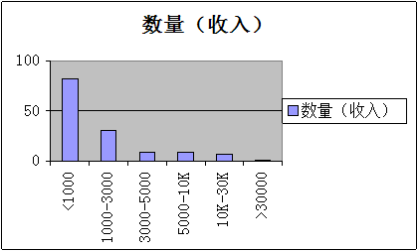

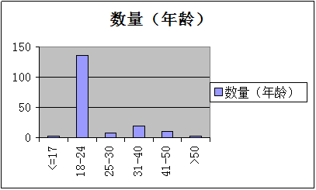

Most people we surveyed are undergraduates from 18 to 24 year- old, despite the fact that their income is not very considerable, they provide us with some initial impression of the 3D technology.

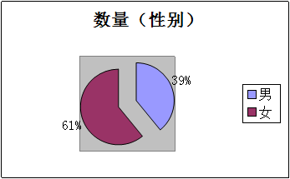

From this pie chart, we can see that more (more than 60 percent of them) female care for our survey about the production. Maybe it more concerns with our daily life. So if it is possible, we'll try our best to investigate and develop more relating software in due course.

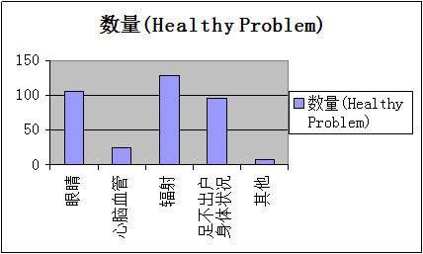

When it comes to health, we all care a lot about it. Most surveyed people are worried about their eyesights, the dangers of the radiation, as well as weakened bodies caused by a long time home-staying without exercising.

Now, let we describe our IIROOM from the health angle. We use a facility called overhead projector which gives out light onto the wall to show what we want to see. So the harm to our eyes is less than our ordinary monitor screens.

It is a little bit difficult for us to analyze the underlying problem of radiation. But we believe that with the development and the melioration of it, the quantity of possible radiation will be cut off gradually.

Worries about laziness can surely disappear, for our ideal production is related to a huge amount of daily-life software, including something about exercise, which use the technique of skin-feeling to show a live game that you can join in.

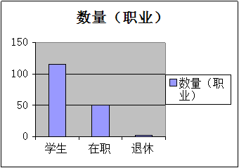

From this chart, it can be described that more youth care for it than the seniors. Because these persons enjoy experiencing new items, we'll get our market more cater to those junior people and develop more creative functions for them. As our productions come into maturity gradually, we'll think more about the seniors' market; maybe we'll concentrate more on medical care and health for them, to contribute more benefits to our society.

（II）

marketing research

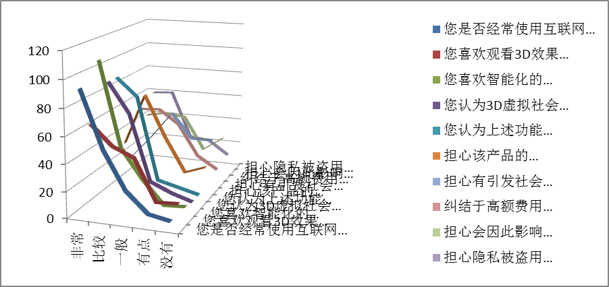

marketing research

“Science and technology constitute a primary productive force."--said by Deng Xiaoping

With the development of the science and technology, there are more and more new and high-tech productions provided by many kinds of companies. Now, almost few people are still satisfied with the ordinary style to spend their leisure time and to show their own understandings towards the meaning of life. So we need to deal with core problem of it. With the development of IIRoom, we are sure, one day, if it is put into use successfully, there will be an enormous possibility that it will bring a new technical revolution and make our working and daily life more relaxed .As we can see from all the charts shown above, whether people we investigated are male or female, young or old, students or workers, with high education or low education, whether they are rich or not, their expectations of our system are good to our promotion. Their unlimited expectations also give us unlimited motive power.

However, science and technology is a two-edged sword. It seems that our IIROOM also have some underlying problems, from the difficulty we may meet in developing it, in some hidden dangers of social turbulence and moral issues, and just as many people concern that it may cause embezzlement of our personal information .But all of the problems we are facing today will be solved one by one What we want to do is just to reduce the potential threats, to make our society more harmonious.

We won’t stop our steps by just producing a few common products. We’ll deal with more issues, more concepts, and more problems during our daily life and our daily work.

**Summary**

Great feature of 3D Somatosensory System

With all the statistics in mind, we find that we need to promote a better system, a better function, besides an easier man-machine interaction is more needed.

Judging from the above diagrams and charts, we need to do more works on the operation of our system .What's more, we should pay more attention to our customs, whether they are old or young, whether they use the Internet just for fun or do their important business affairs .Once our system put into use, we need to concerns more about our effects in our modern society .With the intention of associating with more areas of our society, we must do a lot to the expansion of business.

''Somatosensory system of 3D has a great potential power." Just like what the microblog from Sina said. Our duty of developing this technology is not only dealing with the individual, but also consisting of various fields of our company, and government. We should pay highly attention to the development our nation, our global and even our planet. We are just trying to build a virtual society, a society full of unity, full of peace. We want to spread convenience and efficiency to all the people in our country instead of crimes and violence. As for people show much concerns towards our principals of the development of our system, we want to emphasize the security of our software. We try to build a rigorous network system, which allow very few people enter into the inner system of our service .We try to protect every piece of information that people try to share and obtain during the using. To solve the problem ,we will build a stack of the Internet security .Simultaneously

,we want to optimize the whole level of our technology to bring advanced software to all of our society.

Now ,we would like to talk some detailed information of the relationships between products and market ,sales and price. In order to gain better sales performance ,we try to make the product have the sense of the hommization ,and to try to combine our technology with other kinds of existing technology .Besides, we try to embed the core technology in farms ,manufacture ,handicraft industry ,tourism and many kinds of other domains . We try to enlarge our market by promote the quality of our products .Maybe you will find that more and more disabled people will use our products .Needlessly to say, we will bring convenience to all kinds of people .We want to show the world a brand new era of intelligentized system just like what Apple has shown the world.

Certainly ,we want to spread the products to the places as many as possible .So we need to come up with the idea of lowering our expenses without lowering the quality of our products .We just want to use the integration to gain a more attractive appearance .We can try to use to different kinds of ways to make sure the profits of our products .Firstly, we try sell the client one by one ,and the customs can use the in the long run. Secondly, we try to sell the software by charge fees month by month or year by year .Last but not least, we will sell our software to Business alliance ,we will also sell our products to the 3rd party ,we want to share our technology to all areas of people . We want to be not only a provider but also a core center.

Maybe you may get much confused with our technology. So we will establish a new platform for our customs to share their experience .Just like current policy of our country ,we also “start with people” .We will collect every feedback from our users , we will grasp the every commercial opportunity to promote the economic growth of our society . Notably, we will provide more opportunity for our users to create their favorite terms .We won’t just concentrate our products on a certain small area, we will switch our skill from games to decorations, shopping and some other kinds of daily activities.

To sum up, we will use five ‘’i’’ to describe our products:

**intelligent ,interaction ,ideal ,impact ,I can!**